

**Assignment: 2 (Python Project)**

**(Individual Report)**

**Submitted By: Anupam Dhakal**

**Student Id: 1815430**

**Submitted to:**

**University of Bedfordshire (U.O.B)**

**Individual Report:**

Programming was one of the most important part of my life. From my childhood days programming was in my mind. I thought that how that programming was possible and tried to know the answers. In my university level I joined University of Bedfordshire in which Level 4 Semester 1 provided us with the group project of python as the Shared Power. I felt very overwhelmed and excited at the same time when I saw the notice about the group members.

|  |  |  |  |
| --- | --- | --- | --- |
| **S. N** | **Name** |  | **Student ID** |
| **1.** | Kshitij Bajagain |  | 1723333 |
| **2.** | Anupam Dhakal |  | 1815430 |
| **3.** | Dinesh Timalsina |  | 1815429 |
| **4.** | Ram Prasad Ghimire |  | 1816707 |

Grouping of four was made including me, Dinesh Timalsina, Kshitij Bajagain and Ram Prasad Ghimire. Working with Kshitij, Dinesh and Ram was very much convincing. I feel lucky to be in a group who knows how to utilize our strengths and accept the weaknesses. All of the members in the group were good at communication with each other. We had great time together learning how the object class and functions work, how project work should be divided and what does co-ordination mean. All of the members equally contributed to the team and helped the group to move forward effectively.

According to me, organizing the group and dividing the task was toughest job for us. Being a group leaders it was my prior duty to manage all of the views and contributions of the members in the group so I had a very tough time in maintaining contributions for all. Group organization was very much nicely done in our group.

|  |  |  |
| --- | --- | --- |
| **S. N** | **Name** | **Work Division** |
| **1.** | Kshitij Bajagain | User Panel, Search Tools, Hire Tools, Upload Tools , Class Diagram |
| **2.** | Anupam Dhakal | Login , Register, UML Diagrams(Sea level, Fish Level), Slides |
| **3.** | Dinesh Timalsina | Return Tools, Payment , Invoice Generation, Clam level Diagram |
| **4.** | Ram Prasad Ghimire | Insurance agent profile design, Activity diagram, Analysis of software |

We were determined about learning new skills and applying it in our project so all of us wanted to do every job on our own. All the members in the group together had an amazing time and made good things happen in the software. We had a discussion about it and finalized that how to complete our project. All of the group members were very supportive to me and helped me a lot in my jobs. Helping all of the members in our group was the main goal which has been very helpful for doing our jobs in the projects. All of my friends in the group did their respective work which I had divided to them very effectively. Some problem arise when all of the coding should be assembled into the whole program as all the members has used their techniques in doing their part of work. I also helped my friend Kshitij in his part of coding and provided some techniques in the code.

Since I was assigned for the:

* Register(Both GUI and Coding)
* Login (Both GUI and Coding)
* Use case diagrams (Sea Level and Scenarios)

The major problem that I faced during the project was of validation part. It was very tedious jobs for the first time. But as the time passed by I finally came with the solution and was able to complete the validation of the software efficiently. I took help from my mentors and my friend Kshitij and finally came to the solution of that part. All my friends were good in doing their jobs very effectively. My friend Dinesh helped me in Calm level of the Use Case which made my coding a bit easier. Hashing of the password had also been one of the problem which I solved by the help of my teacher and some research over the internet.

In group, every member worked perfectly and evaluating their work I have attested a table below which rates their work during project development.

|  |  |  |  |
| --- | --- | --- | --- |
| Student Number | First Name | Last Name | Contribution  (N,S,I) |
| 1815429 | Dinesh | Timalsina | S |
| 1816707 | Ram | Ghimire | S |
| 1815430 | Kshitij | Bajagain | S |

* **S** -Significant (The group member’s work was integral to the overall submission)
* **N** -No Contribution (The group member took no part in the project submission)
* **I** -Insignificant (The group member’s work made little difference to the overall submission)

In conclusion all of the members of the group worked well as the final output is good. A quality software is produced by the whole group. There were some of the ups and downs at the previous time but later on all of these ups and downs were solved. I did not find any bad qualities in them which hampered our project. Additionally, I got to know a lot of things about myself during this project. I realized that I work more effectively in a group than alone

UML Diagrams :( Sea level and Scenarios)

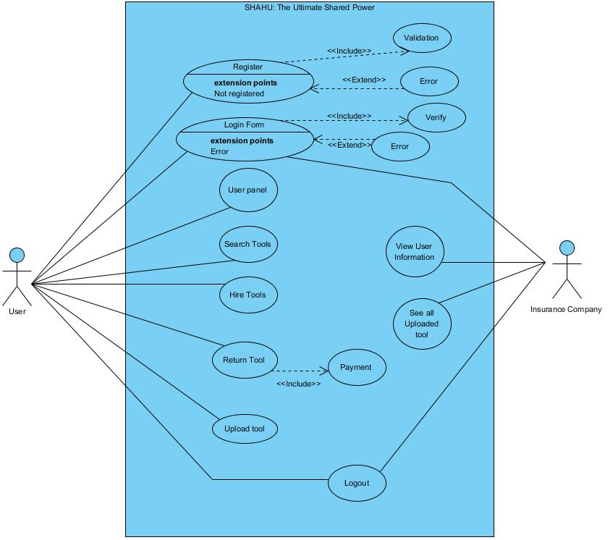

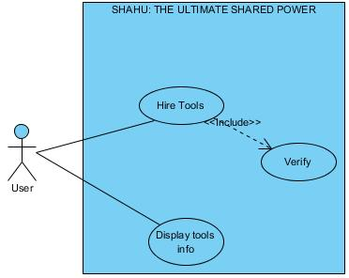 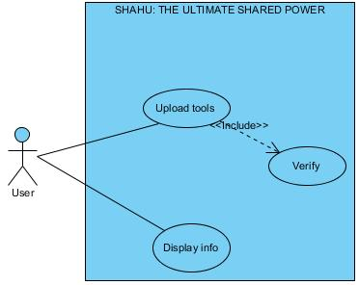

Scenerio 1: Scenerio 2:

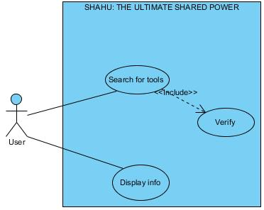 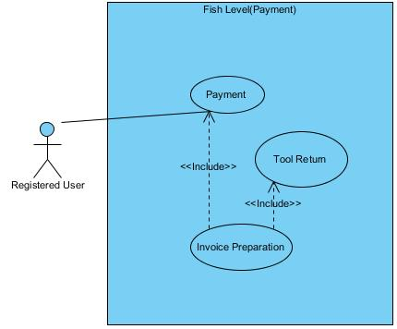

Scenario 3: Scenario: 4

**\**

**Appendix:**

CODES for LOGIN PAGE:

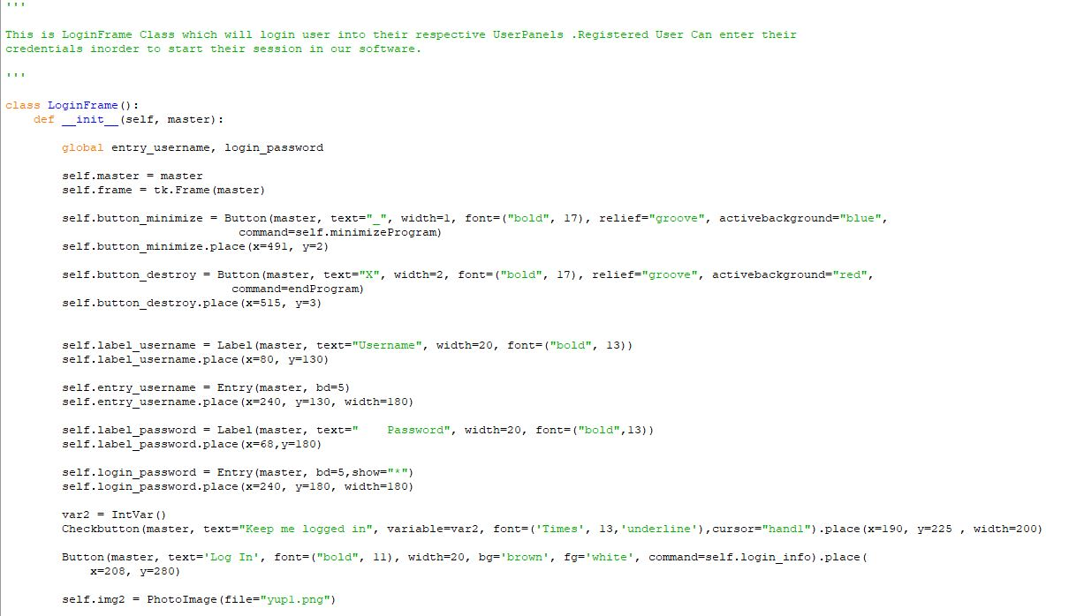

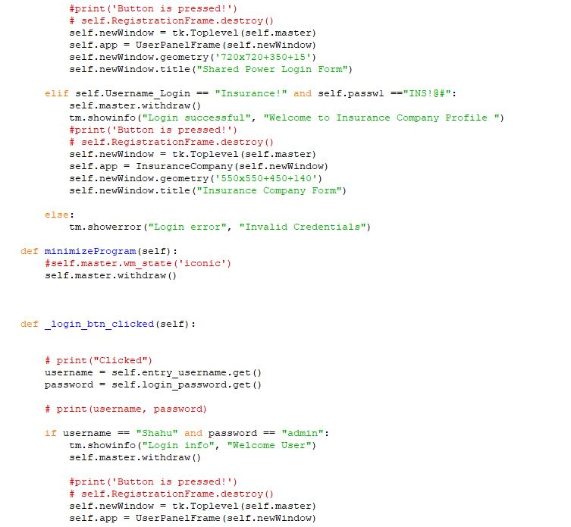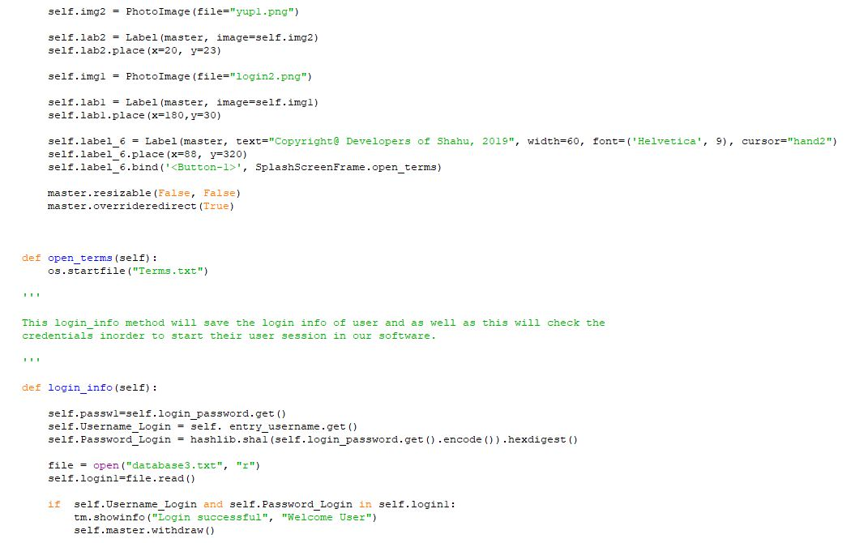

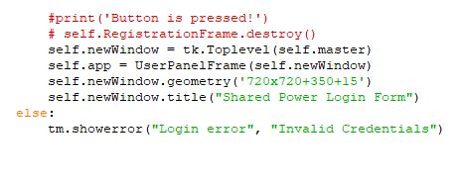

Codes Registration Panel:

